Comments based on MK test dated: 6/17/2026

Comment 1: The tool still does not work for the case of L shape is selected. You may check with the offline tool with Phani. Also, the shape in the menu should look like L-shape (now it looks like a step shape).
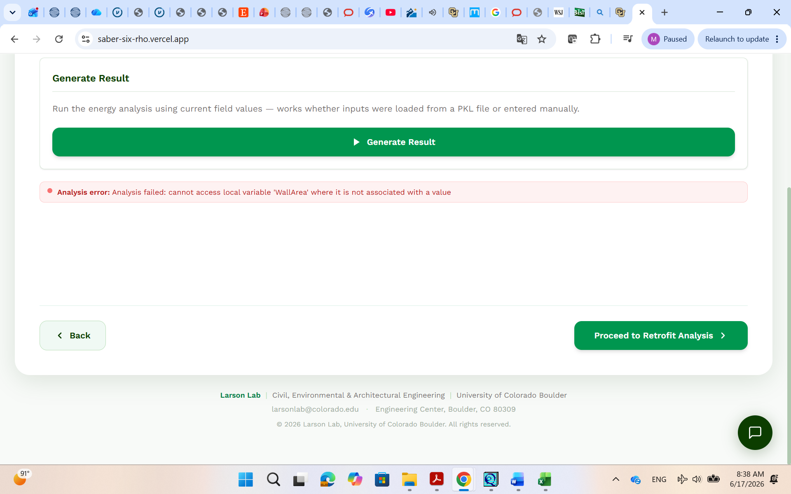

Comment 2: The tool works for a rectangular shape (Great!)
Comment 3: Improve the pie chart so the labels for various end-uses do not overlap. You may use the legend of monthly legend including the color for each end-use (see later) for this pie chart.
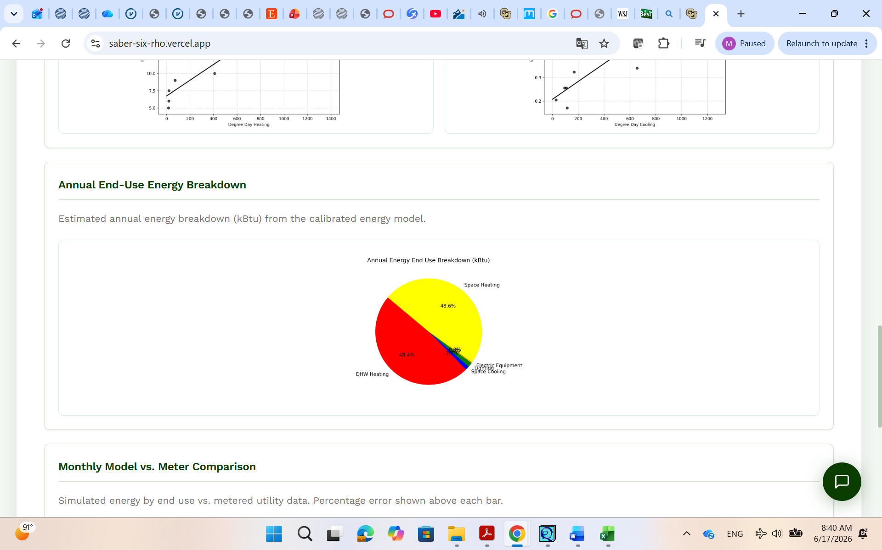
Comment 4: The legend with the color labels for the monthly charts is missing. We agreed that this legend can be added below these charts.
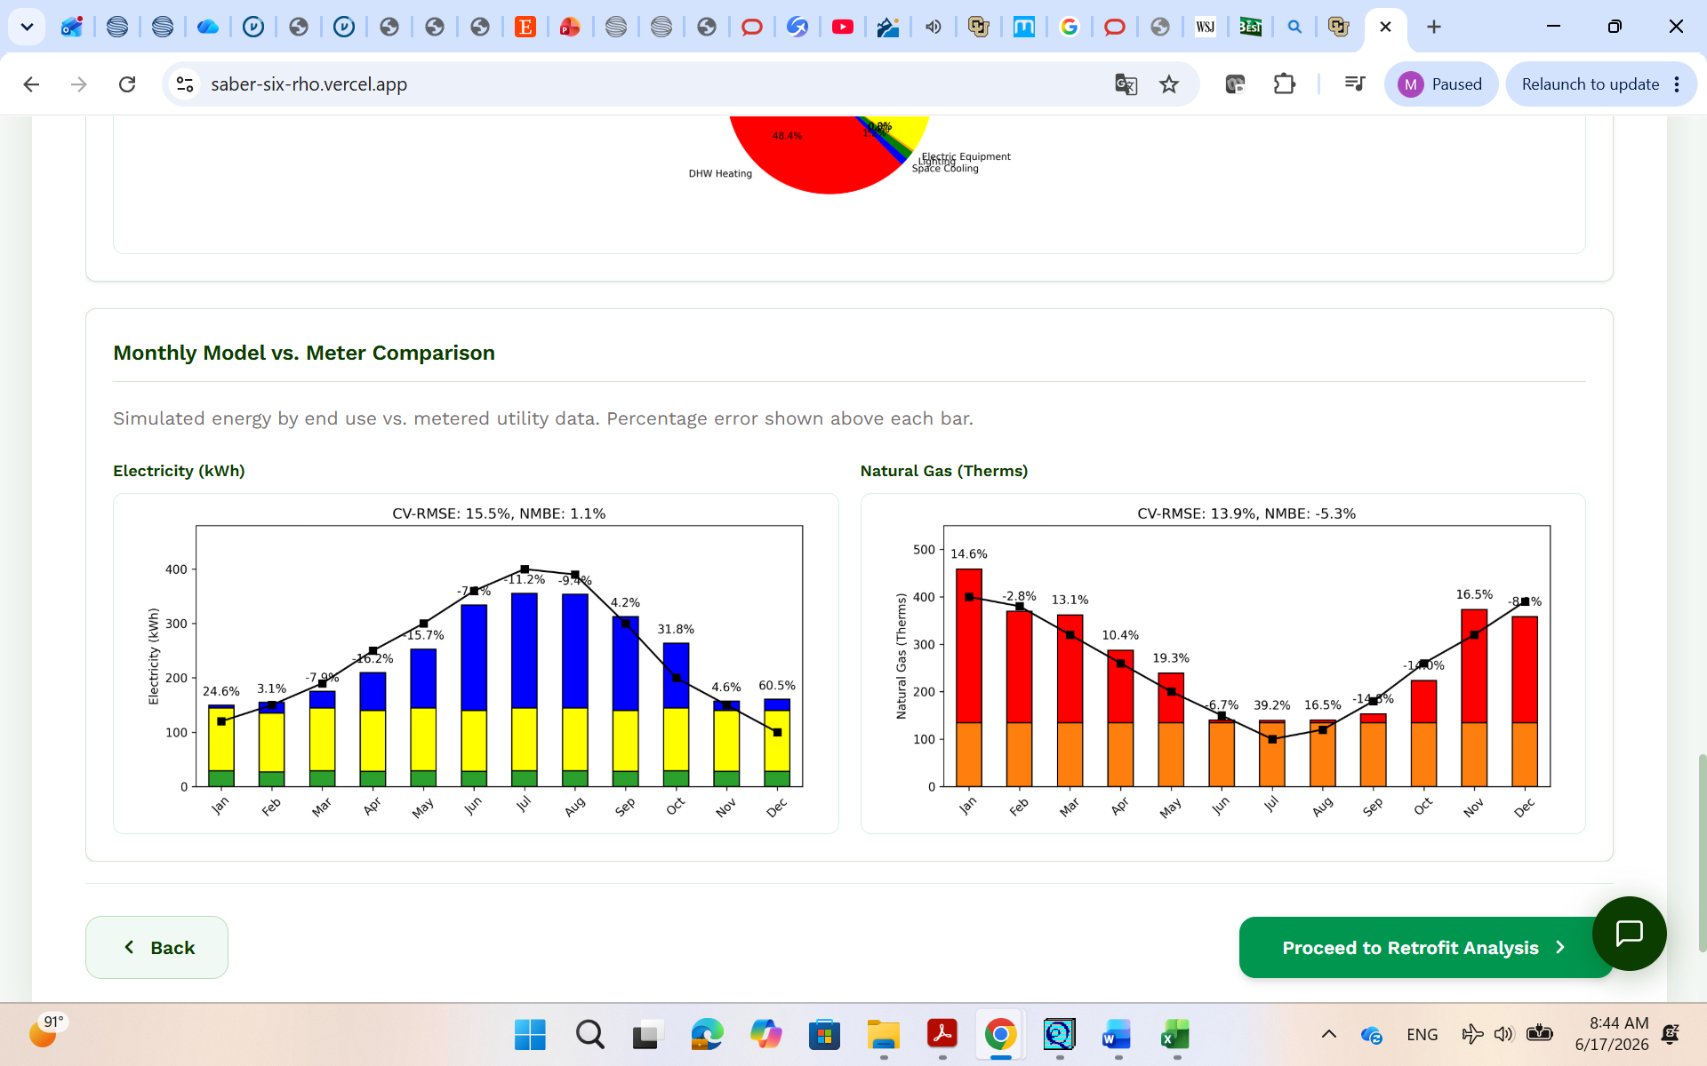

Comment 5: Add the option for the user to add the cost for each selected retrofit measures (You can show the default costs but the user can change it).
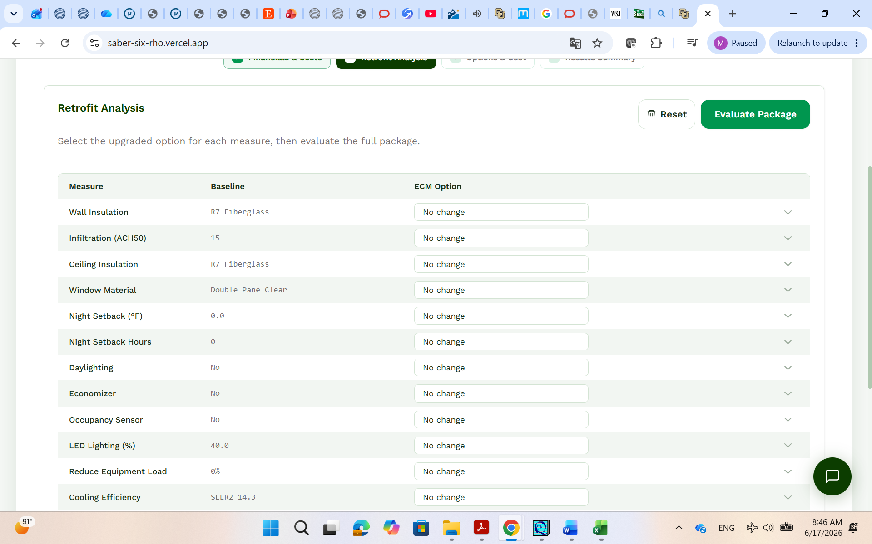

Comment 6: Show only the total cost for each measure (instead of labor and material) and show the payback period for each measure as well as the payback period for the package.

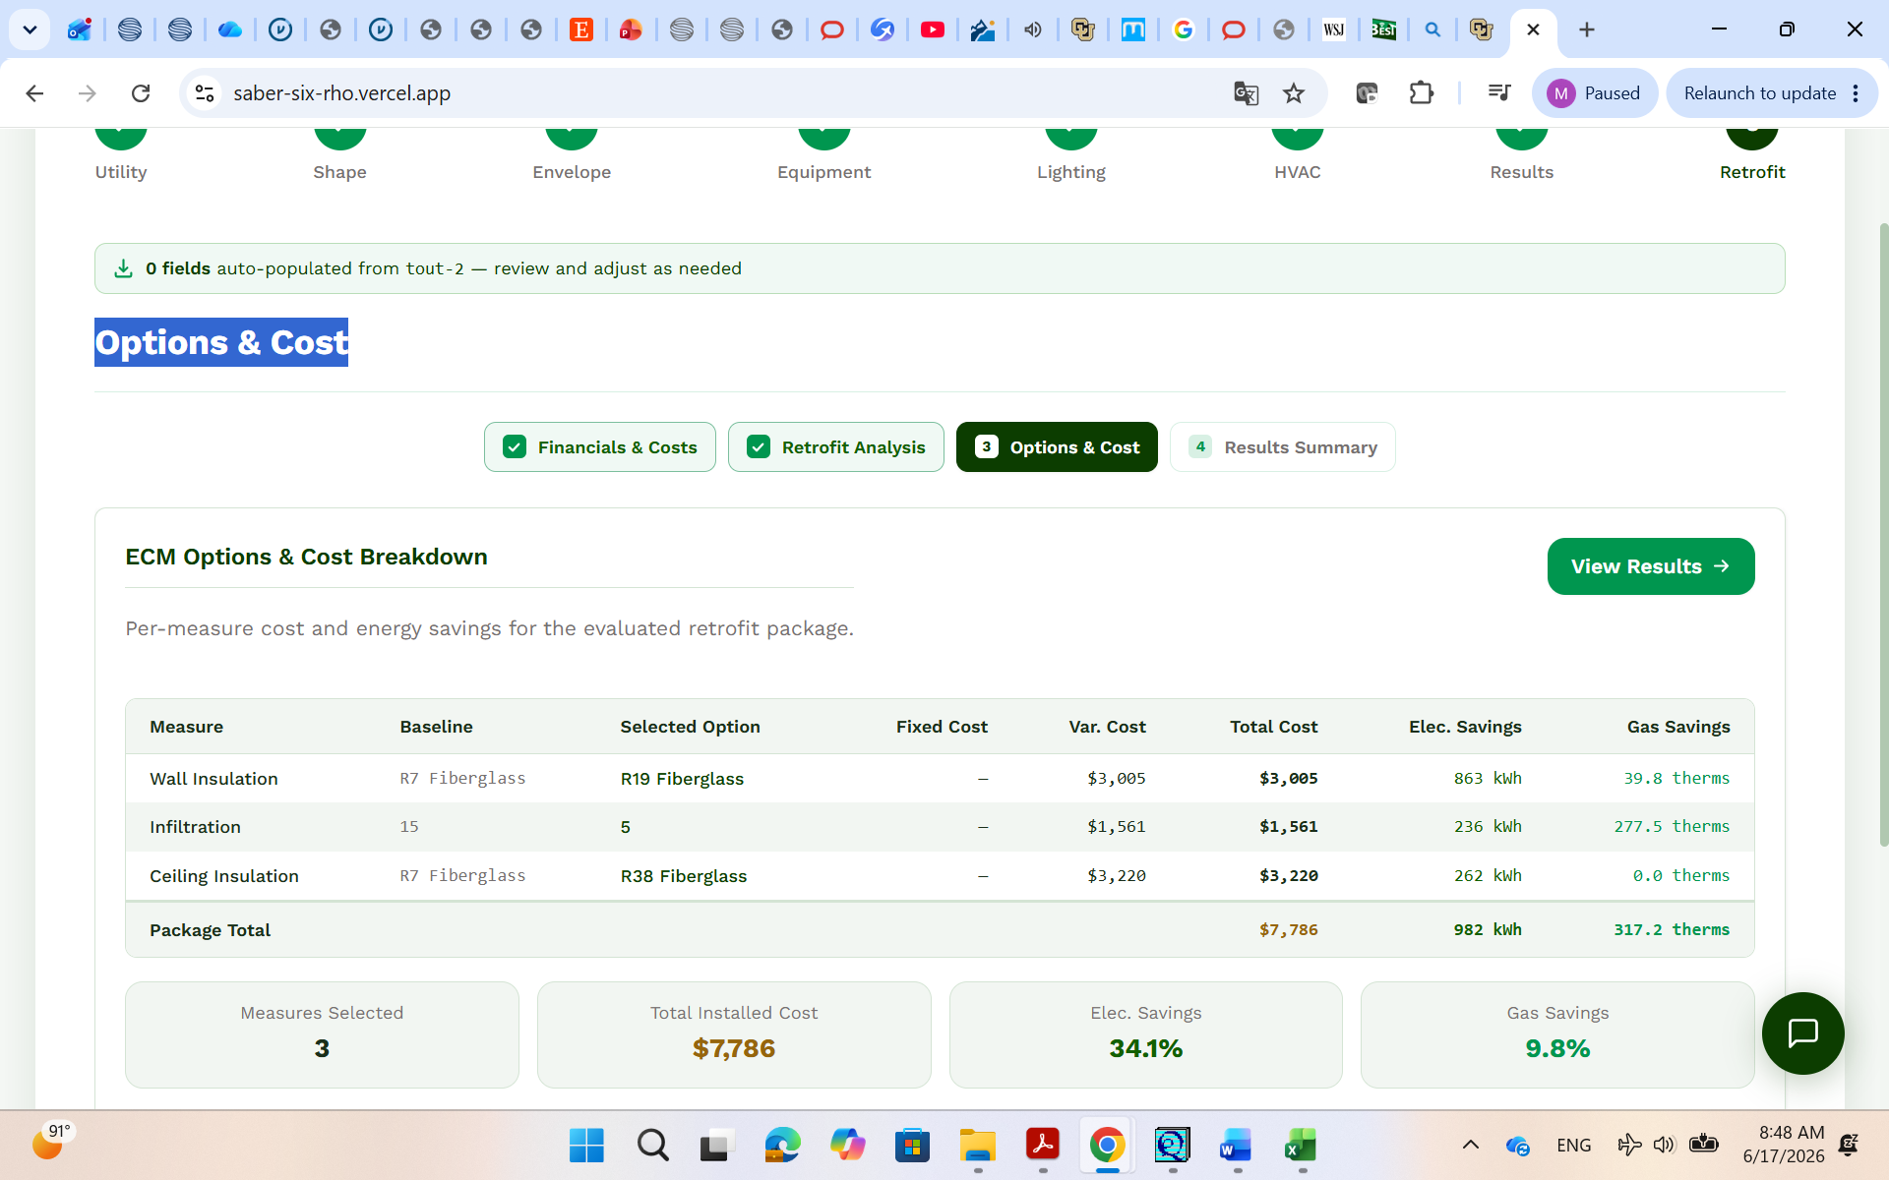

Comment 7: Better use a Table format to provide the summary analysis and include the annual electricity savings (kWh/yr), natural gas savings (Therms/yr), payback period, and net present value (difference between the baseline LCC and the project LCC). You may work with Phani to get the simple payback period.
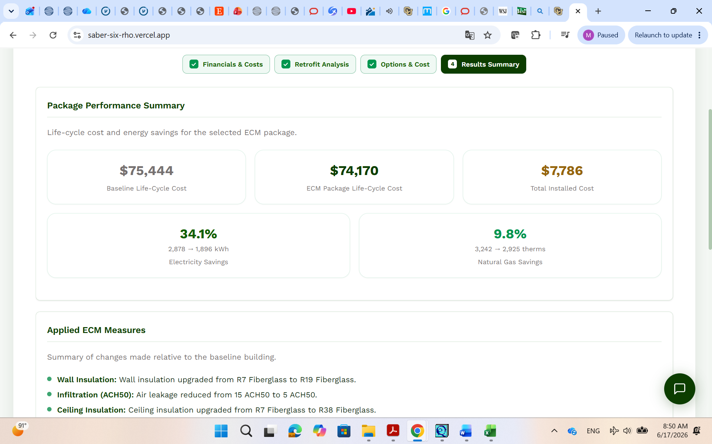
Comment 8: Add a color legend for the monthly charts.
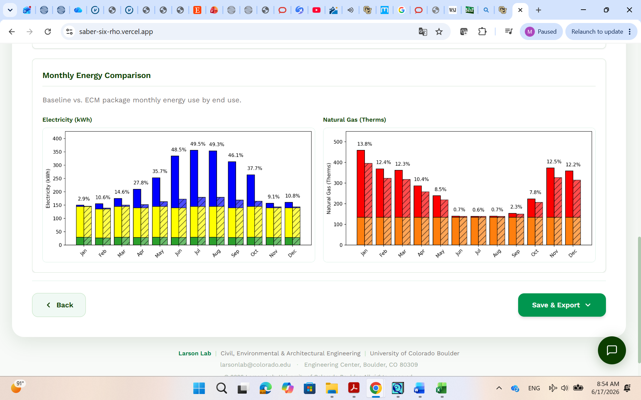

Comment 9: Various editorial changes
- Replace in title of input screen 7 “Results” by “Analysis”
- Replace “Generate Result” by “Perform Analysis”
- Replace “ECM” by “EEM” everywhere (most in the input section of Retrofit and associated results).
- Replace “ECM Options and Cost Breakdown” by “Energy and Cost Benefit Analysis”
- Replace “Per-measure cost and energy savings for the evaluated retrofit package” Evaluation of cost and energy benefits of all selected EEMs for the retrofit package”

